1. 
2. 
3. Elasticsearch is the core in ELK stack.
4. To work with Elasticsearch we need to feed it with data.
5. **LogStash**:
   1. The Elasticsearch stash provides the tool called **LogStash** to pull the data from the **source system** and push it into the elasticsearch.
   2. Logstash is
      1. open-source,
      2. server-side data processing pipeline that ingests data from a multitude of sources simultaneously, transforms it and then sends it to your favourite “stash”.
6. ***Kibana***:
   1. Kibana is a **visualizing tool** to communicate with elasticsearch.
   2. It provides a rich user interface for the developer to play with the data available in the **elastic cluster**.
   3. We use kibana to **search**, view, interact with data stored in the elasticsearch indices.
   4. We can easily perform advanced **data analysis** and visualize your data in a variety of **charts, tables, and maps**.
7. Let’s install this package.
8. For now, we will install Elasticsearch and Kibana. Logstash later on.
9. 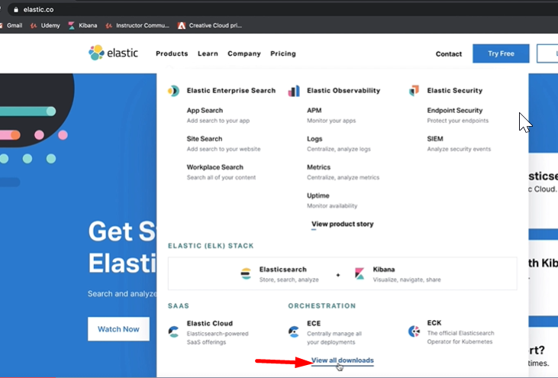
10. 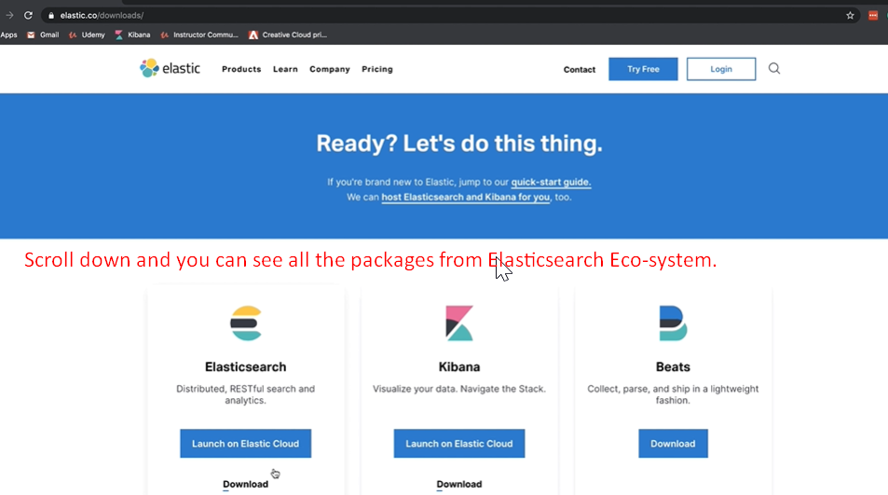
11. 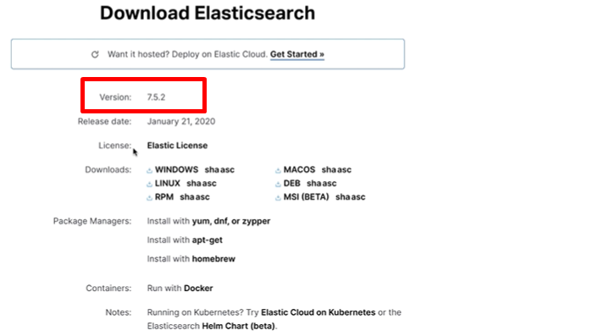
12. 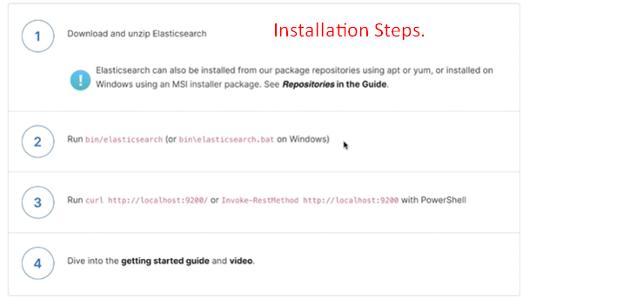
13. By running the elasticsearch.bat file, we can start **elasticsearch server instance**.
14. 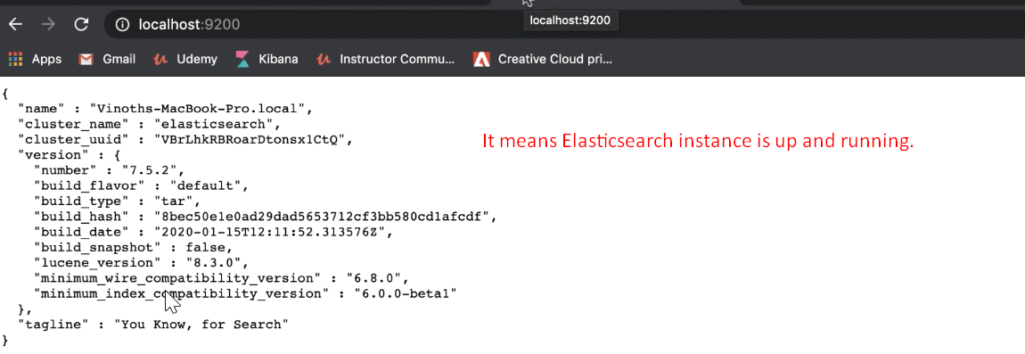
15. Let’s install Kibana.
16. 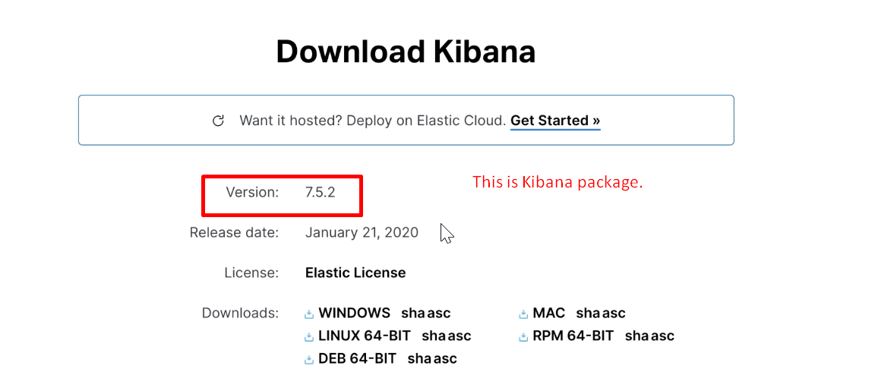
17. 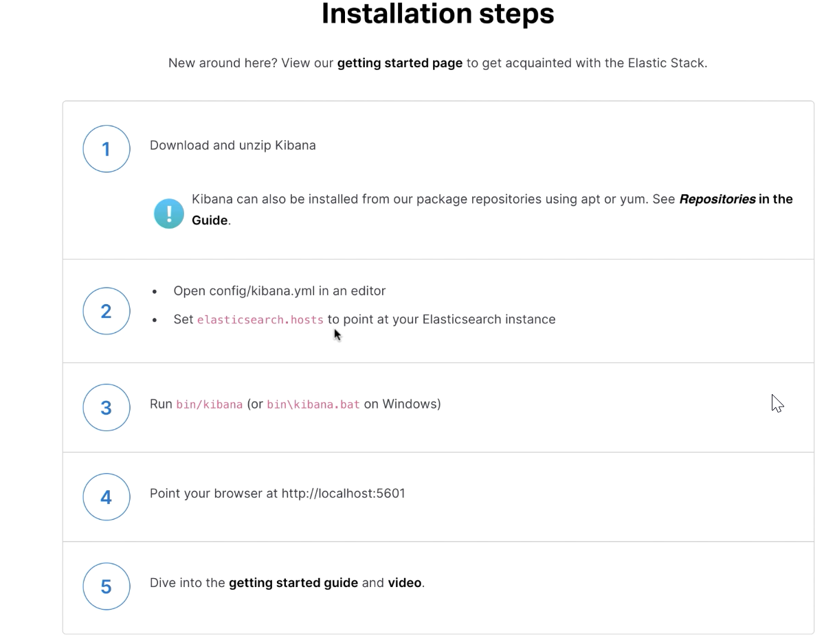
18. 